**Programming Fundamentals**

Muhammad Athar Abbas

**SP25-BSE-082**

Section A

**Theory Assignment 2**

**Code:**

1 #include *<iostream>*

2 #include *<iomanip>*

3 **using** **namespace** **std**;

4 int main() {

5 cout << "Muhammad Athar Abbas" << endl;

6 cout << " Sp25-bse-082" << endl;

7 cout << " Section A" << endl;

8 cout << setw(27) << setfill('=') << '=' << endl;

9 cout << endl;

10 int start;

11 int last;

12 cout << "Enter the start of the range: ";

13 cin >> start;

14 **while** (start < 0) {

15 cin.clear();

16 cin.ignore();

17 cout << "Invalid range. Please ensure both numbers are positive integers and start is less than or equal to the end."<< endl;

18 cout << "Enter the start of the range: ";

19 cin >> start;

20 } ;

21 cout << "Enter the end of the range: ";

22 cin >> last;

23 **while** (last < 0 || start > last) {

24 cin.clear();

25 cin.ignore();

26 cout << "Invalid range. Please ensure both numbers are positive integers and start is less than or equal to the end." << endl;

27 cout << "Enter the end of the range: ";

28 cin >> last;

29 }

30 cout << endl;

31 cout << setw(27) << setfill('=') << '=' << endl;

32 cout << endl;

33 cout << "Composite numbers between " << start << " and " << last << " are: ";

34 int com_sum = 0;

35 int number = start;

36 **for** ( number ; number <= last ; number++ ) {

37 **for** (int divider = 2 ; divider < number ; divider++) {

38 **if** ( number % divider == 0) {

39 cout <<number << " ";

40 com_sum += number;

41 **break**;

42 }

43 }

44 }

45 cout << endl;

46 cout << "The sum of Composite number is " << com_sum << endl;

47 **return** 0;

48 }

**Outputs:**

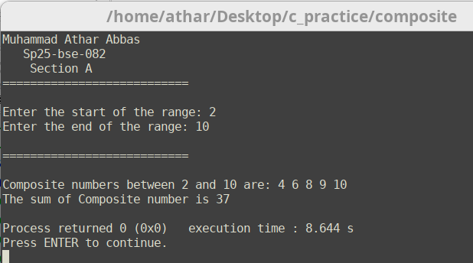

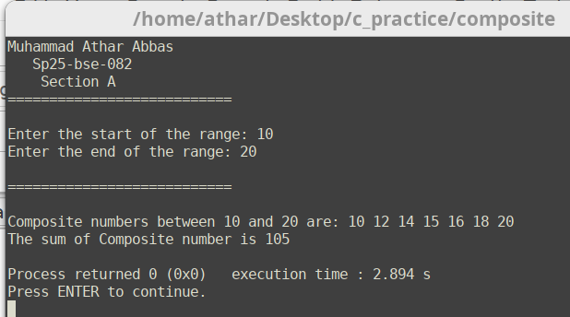

**Input Validation:**

